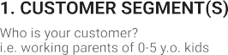

**Project**

**Title:**

***Smart Fashion Recommender Application***

**Project**

**Design**

**Phase**

**-**

**I**

-

**Solution**

**Fit**

**Template**

**Team**

**ID:**

**PNT2022TMID11603**

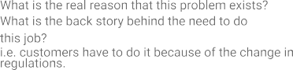

w--wasususihuh

-wandering customers

-Need based shoppers

-Unhelpful customer service

-Quality level

-Collaborative based on filtering technique

-content based filtering technique

Consumers-search-select-purc

Purchase-use-dispose of goods

-The model can only make recommendt

-Poor tracking

-Logistics

-Long delivery

|  |  |  |  |  |  |  |  |  |
| --- | --- | --- | --- | --- | --- | --- | --- | --- |
|  | **3. TRIGGERS TR**  What triggers customers to act? i.e. seeing their neighbour installing solar panels, reading about a more efficient solution in the news. | | | **10. YOUR SOLUTION SL**  If you are working on an existing business, write down your current solution first, fill in the canvas, and check how much it fits reality.  If you are working on a new business proposition, then keep it blank until you fill in the canvas and come up with a solution that fits within customer limitations, solves a problem and matches customer behaviour.   |  | | --- | | Based on the search history & selected product the recommendations will be suggested with extra features | | 1. **CHANNELS of BEHAVIOUR CH**     1. **ONLINE**   What kind of actions do customers take online? Extract online channels from #7     * 1. **OFFLINE**   What kind of actions do customers take offline? Extract offline channels from #7 and use them for customer development.   |  | | --- | | ONLINE: Search , Buy , Pay  OFFLINE:Get , Use , Give feedback | |  |
|  | -Scarcity  -Urgency , Reciprocity |  |
| **4. EMOTIONS: BEFORE / AFTER EM**  How do customers feel when they face a problem or a job and afterwards?  i.e. lost, insecure > confident, in control - use it in your communication strategy & design.   |  | | --- | | Issues on the product quality  Hidden cost | | | |